**Steps to raise exceptionss in FM (No customer)**

1. Go to se37 and create FM starting with Z/Y

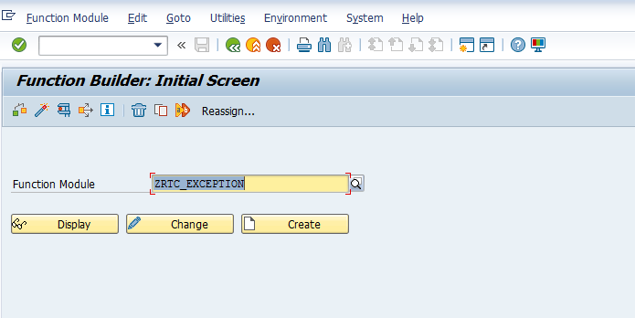

1. In the import tab, add one parameter im_kunnr to take customer no.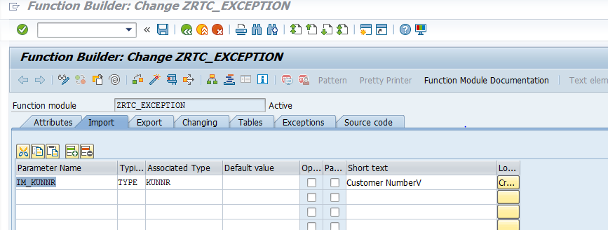

3. In the exports tab, declare a work area wa_kna1

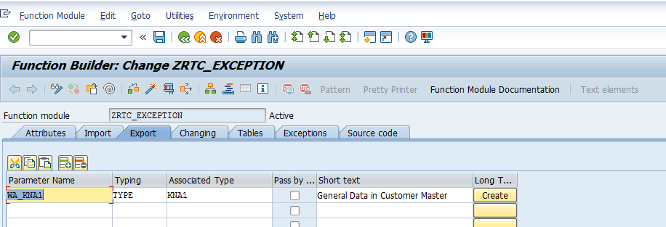

4. In the Exceptions tab, add the below

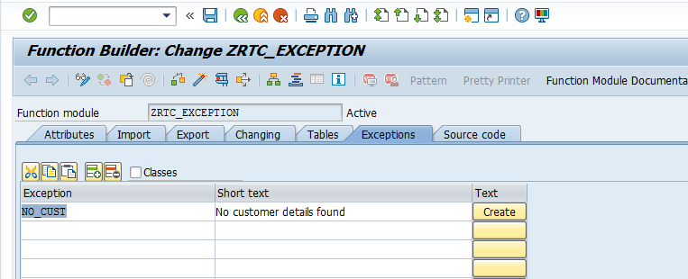

5. In the source code tab, add the below code

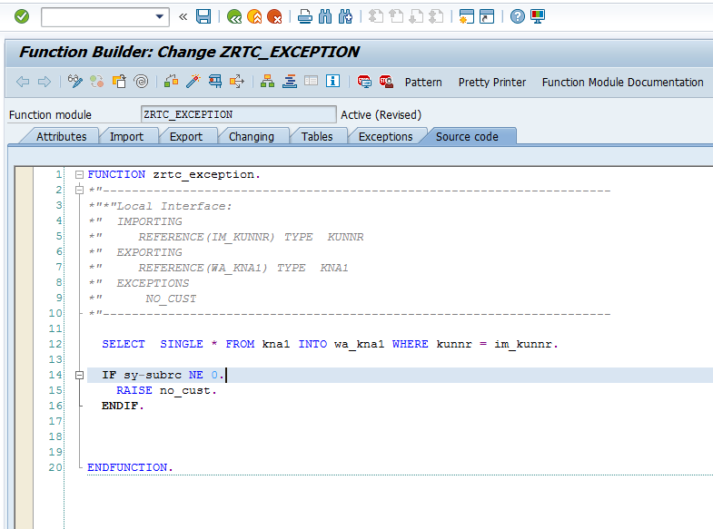

6. Save and activate the FM

7. Call the FM ZRTC_EXCEPTION in your report

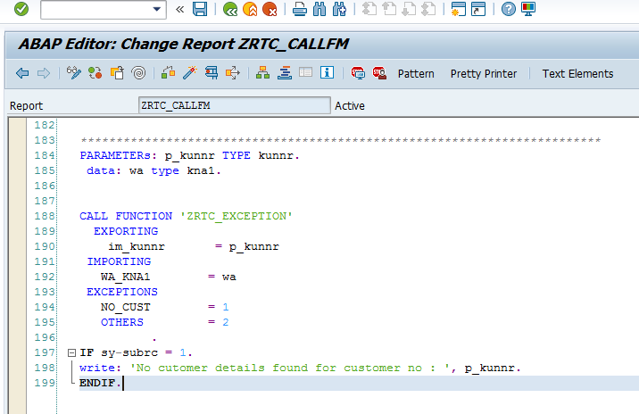

Code:

\

*\*&---------------------------------------------------------------------\**  
*\*& Report ZRTC_CALLFM*  
*\*&-------------------------------------------------------------------*  
  
REPORT zrtc_callfm.  
PARAMETERs: p_kunnr TYPE kunnr.  
 data: wa type kna1.  
  
  
CALL FUNCTION 'ZRTC_EXCEPTION'  
  EXPORTING  
    im_kunnr       = p_kunnr  
 IMPORTING  
   WA_KNA1        = wa  
 EXCEPTIONS  
   NO_CUST        = 1  
   OTHERS         = 2  
          .  
IF sy-subrc = 1.  
write: 'No cutomer details found for customer no : ', p_kunnr.  
ENDIF.

7. The expected output is as below:

